Project Design Phase
Solution Architecture
Date | 28 September 2026
Team ID | SWTID-2026-8108
Project Name | AI FAQ Assistant
Maximum Marks | 4 Marks

The architecture diagram shows how requests pass from API clients through the Express application to secure controllers, MongoDB, and Google Gemini.
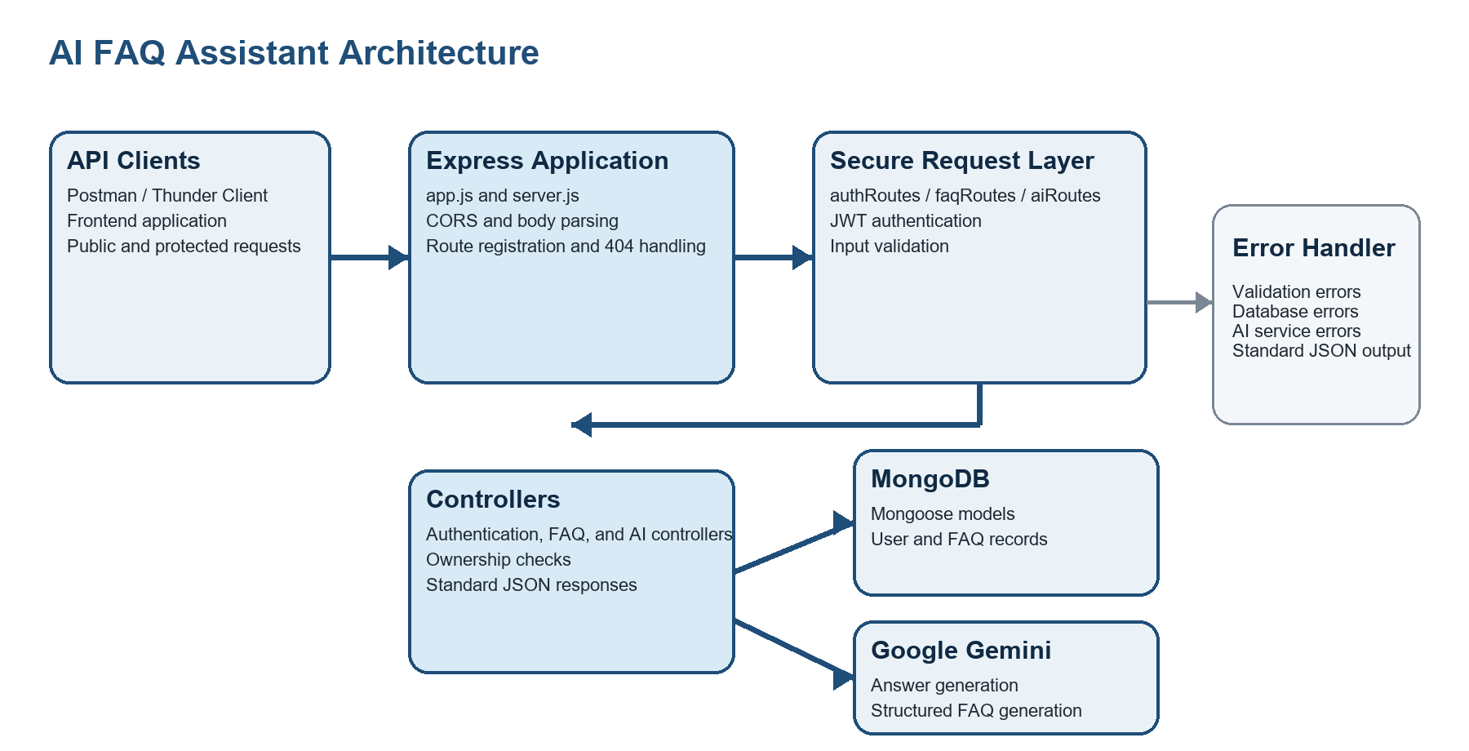
Figure 1 AI FAQ Assistant backend architecture and request flow
Architecture Flow
Stage | What happens
Request entry | Postman, Thunder Client, or a frontend sends a REST request to /api/auth, /api/faqs, or /api/ai.
Secure processing | Routes apply request validation and, for protected operations, verify the JWT before controllers run.
Business and data processing | Controllers use Mongoose models for MongoDB data and geminiService for AI answer or FAQ-pair generation.
Response and errors | The API returns standardized JSON. Centralized error middleware formats validation, database, and service failures.

